Author: Diego Osorio

Date: 05/05/2023

**Understanding the Spatial Distribution of Minnesota’s Invasive Species**

1. **Introduction**

In Minnesota, there have been over 170,000 observations of invasive species, with the majority being terrestrial (~137,000) and the rest being aquatic (~35,000). These species are responsible for causing the second most significant loss of biodiversity worldwide (Madren, 2011), resulting in an annual cost of over $21 billion to the US economy (Sheridan, 2022). In Minnesota alone, invasive terrestrial plants cause a yearly cost of approximately $3 billion (UMN, n.d.). Therefore, it is crucial to examine the environment in which these species thrive and establish environmental management programs accordingly.

This project aims to analyze the land-cover types where invasive species have been observed and the counties that have been affected the most. It also aims to investigate potential correlations between invasive species and previous wildfires. This is because invasive species are known to exploit disturbance events, such as fires, to colonize new ecosystems (USDOI, n.d.). Hence, this project can provide valuable insights into managing invasive species in Minnesota by examining these factors.

1. **Database description**

Figure 1 displays the database structure, consisting of six tables. Two tables represent observations of invasive species, one for terrestrial and the other for aquatic species. These two tables can be combined into a single table using the Union function since they share the same field names and types. Another table in the database represents the wildfires tracked by the Minnesota Department of Natural Resources. All of these tables have a one-to-many relationship with the Minnesota counties table. Finally, at the bottom of the figure is a table created from the land cover raster dataset, containing only the rid and raster information of the tiles. The land cover table is intersected with a point geometry using the ST_Value function to identify the specific land cover classes for each observation or wildfire. This intersection returns the values for each pixel in that area, which are then joined to a table that describes the land cover class for each pixel value. This process enables classifying each observation or wildfire by the corresponding land cover class.

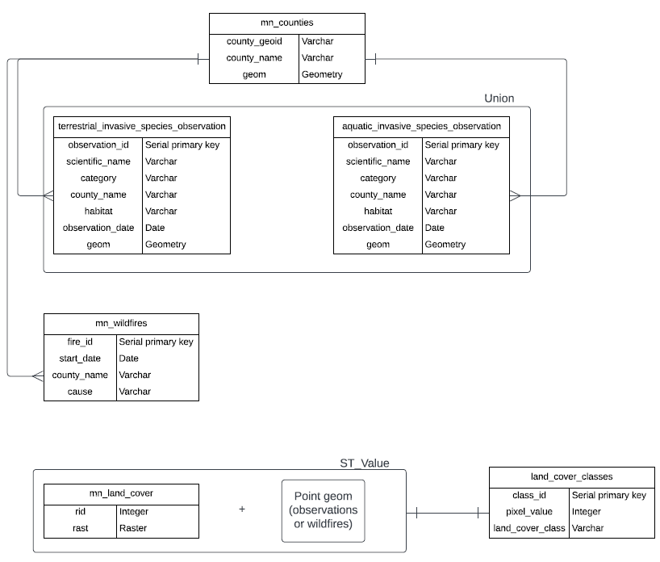

Figure 1. Database schema

1. **Methods**
   1. **Data**

Table 1 summarizes the data used in this project, all obtained from the Minnesota Geospatial Commons portal. The data includes diverse types, such as polygon and point shapefiles, a raster dataset, and a table derived from the land cover classification.

Table 1. Data types and sources

|  |  |  |  |
| --- | --- | --- | --- |
| **Name** | **Data type** | **Source** | **Generated or Acquired** |
| MN counties | Polygon | https://gisdata.mn.gov/dataset/bdry-counties-in-minnesota | Acquired |
| Terrestrial invasive species observations | Point | https://gisdata.mn.gov/dataset/env-invasive-terrestrial-obs | Acquired |
| Aquatic invasive species observations | Point | https://gisdata.mn.gov/dataset/env-invasive-aquatic-obs | Acquired |
| Land cover | Raster | https://gisdata.mn.gov/dataset/biota-landcover-nlcd-mn-2019 | Acquired |
| Land cover classes | Table | https://gisdata.mn.gov/dataset/biota-landcover-nlcd-mn-2019 | Generated |
| MN wildfires | Point | https://gisdata.mn.gov/dataset/env-wildfires-tracked-by-mndnr | Acquired |

* 1. **Loading data to database**

The datasets obtained from the Minnesota Geospatial Commons portal were first projected to WGS 1984 in ArcGIS Pro version 3.1.0. The resulting shapefiles were then imported into the PostgreSQL version 15 database using the Shapefile Import/Export Manager app of PostGIS version 3.3.2. Later, in pgAdmin 4 version 6.15, a series of queries were performed to select and rename the relevant columns from the imported shapefiles, create new tables, and generate serial IDs using primary keys. Additionally, the raster dataset was loaded using raster2pgsql in the command prompt and segmented into tiles of 250x250 cells for faster loading. Finally, the metadata from the raster dataset was utilized to create the Land cover classes table, which indicates the class for each pixel value.

1. **Analysis**

The database enables several analyses related to invasive species and their spatial distribution. SQL queries, for instance, can be used to identify the number of terrestrial and aquatic observations per county. This is accomplished by merging the two tables and eliminating the null data. Table 2 shows the three counties in Minnesota with over 10,000 invasive species observations and the three least affected counties.

Table 2. Number of invasive species observations per county. A) The three most affected counties with over 10,000 observations. B) The least affected counties

**A)**

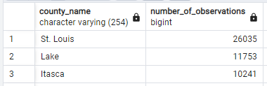

**B)**

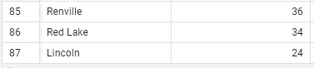

Table 3 illustrates Minnesota's five land cover classes with the most wildfire records. Deciduous forests are by far the most affected by these disturbance events, with over 10,000 wildfires, which makes sense due to the large fuel load, especially in the dry seasons. This result was generated by intersecting the land cover raster with the point geometry of the wildfires to extract the pixel values in those locations and then joining the pixel values to their corresponding land cover class.

Table 3. Wildfires per land cover class

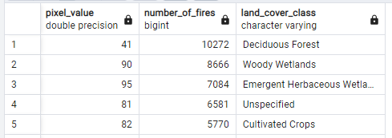

Likewise, the same methodology can be used for analyzing invasive species observations. Table 4 illustrates the top five land cover classes with the highest occurrence of aquatic and terrestrial invasive species observations. As expected, open spaces are the most affected as the lack of competition allows these species to proliferate. Developed areas are also significantly affected since anthropogenic activities often lead to the introduction and spread of invasive species (The National Wildlife Federation, n.d.).

Table 4. Land cover class with the most presence of invasive species observations. A) Aquatic. B) Terrestrial

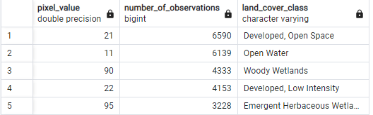

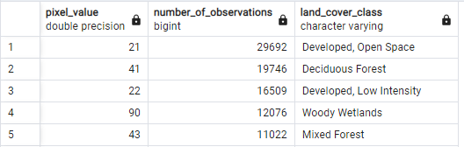

Finally, the database enables spatial and temporal intersections. For example, Table 5 displays the results of a query that identifies ten terrestrial invasive species observations within a 500-meter radius of wildfire records and one year of the fire event. Invasive species are opportunistic and often among the first species to colonize areas undergoing disturbance events (USDOI, n.d.). This is especially true for invasive plants, as they can adapt to poor soil conditions and thrive in areas with limited competition.

Table 5. Ten terrestrial invasive species observations within a 500-meter range from wildfire records and one year after the fire event.

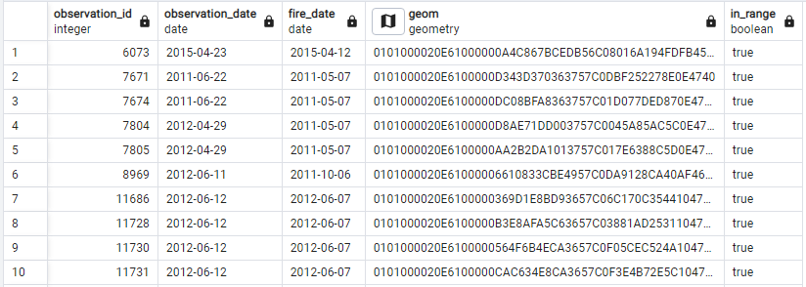

As shown in Table 6, deciduous forests are the most affected by terrestrial invasive species after a wildfire. This table was also obtained by intersecting the latter output with the land cover raster. Figure 2 illustrates the spatial distribution of these observations and the wildfire buffers obtained as query layers.

Table 6. Land cover classes with the most presence of terrestrial invasive species after a wildfire

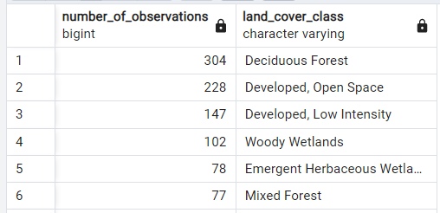

Figure 2. Map of the terrestrial invasive species observations within a 500-meter range from wildfire records and one year after the fire event.

1. **Challenges**

This project also aimed to examine the spatial correlation between invasive species observations and streets. Streets can cause an edge effect that benefits the growth of invasive species, and humans may transport them intentionally or unintentionally, leading to more observations near streets. However, the streets dataset was extensive, with over 440,000 features, and running spatial queries caused pgAdmin to crash. The ArcGIS Pro Dissolve tool was used to create a single feature to overcome this issue. Unfortunately, the dissolved dataset was too large to load onto the database without causing app crashes. Therefore, this objective was dropped from the project's scope.

Additionally, spatial queries involving spatial-temporal intersections took a long time, with 18 minutes to run in pgAdmin and about an hour to be displayed as a query layer in ArcGIS Pro. This was because the datasets had been loaded onto the database with an index for EPSG 4326, but in the spatial analyses, they needed to be transformed into EPSG 26915 to use planar units to create the buffers. Thus, the lack of an index for EPSG 26915 in the loaded datasets caused delays in the analysis. To overcome this issue, the query results were saved into new tables for easier access later.

1. **Conclusions**

The PostGIS database and SQL queries provide a solution for spatial and temporal analysis of Minnesota's aquatic and terrestrial invasive species observations. This enables researchers to identify the most affected counties and land-cover classes by invasive species and track their spread over time. Additionally, the ability to analyze the data separately as aquatic and terrestrial or combined into one table provides a comprehensive view of biological invasions.

The findings agree with the expected trend: developed and open space areas are the most affected by invasive species due to human activities and low competition. In addition, deciduous forests were found to be the land cover class most affected by invasive species colonization after a wildfire. Moreover, special attention is required for St. Louis, Lake, and Itasca counties, which have the highest number of observations. These findings can inform policymakers and conservationists on allocating resources and taking appropriate actions to mitigate the spread of invasive species.

1. **References**

Madren, C. (2011, March 23). *Why invasive plants are the 'second biggest threat to biodiversity' after habitat loss*. Retrieved from Ecologist: https://theecologist.org/2011/mar/23/why-invasive-plants-are-second-biggest-threat-biodiversity-after-habitat-loss

Sheridan, K. (2022, January 4). *Invasive species cost the US $21 billion per year, study finds*. Retrieved from WUSF Public Media: https://wusfnews.wusf.usf.edu/local-state/2022-01-04/invasive-species-cost-the-us-21-billion-per-year-study-finds

The National Wildlife Federation. (n.d.). *Invasive Species*. Retrieved from https://www.nwf.org/Educational-Resources/Wildlife-Guide/Threats-to-Wildlife/Invasive-Species#:~:text=Invasive%20species%20are%20primarily%20spread,carry%20them%20on%20their%20propellers.

UMN. (n.d.). *About MITPPC*. Retrieved from Minnesota Invasive Terrestrial Pants and Pests Center: https://mitppc.umn.edu/about/about-mitppc#:~:text=They%20cost%20Minnesota%20abut%20%243,forests%2C%20prairies%2C%20and%20wetlands.

USDOI. (n.d.). *Teaming Up to Take On the Double Threat of Invasives and Wildfires*. Retrieved from Office of Wildland Fire: https://www.doi.gov/wildlandfire/teaming-take-double-threat-invasives-and-wildfires#:~:text=Often%2C%20invasive%20plants%20have%20an,much%20as%20in%20unburned%20areas.